**Department of Artificial Intelligence**

**College of Computer Science and Information Technology**

***Designing and Styling with HTML and CSS***

1. **Objectives**

By the end of this lab, students will:

* **Apply HCI Principles**: Implement key principles of Human-Computer Interaction to create a user-friendly and visually appealing web page.
* **Use HTML for Structure**: Structure content effectively using HTML elements to ensure clear and organized presentation.
* **Style with CSS**: Utilize CSS to style and enhance the visual layout of the web page, focusing on design, colors, and typography.
* **Design for Usability:** Apply design principles such as simplicity, consistency, and proper alignment to enhance the user experience.
* **Ensure Accessibility**: Design with accessibility in mind, ensuring that the web page is usable by all individuals, including those with disabilities.

**Lab Requirements**

**Software**: A text editor (e.g., Notepad++, VS Code)

**Files**: HTML file (Lab3.html), CSS file (Lab3.css)

1. **Brief on Design, Colors, and Layout Principles**

* **Design Principles**

Consistency: Use similar fonts, colors, and styles throughout to create a cohesive look.

Simplicity**:** Keep designs straightforward and focus on essential elements.

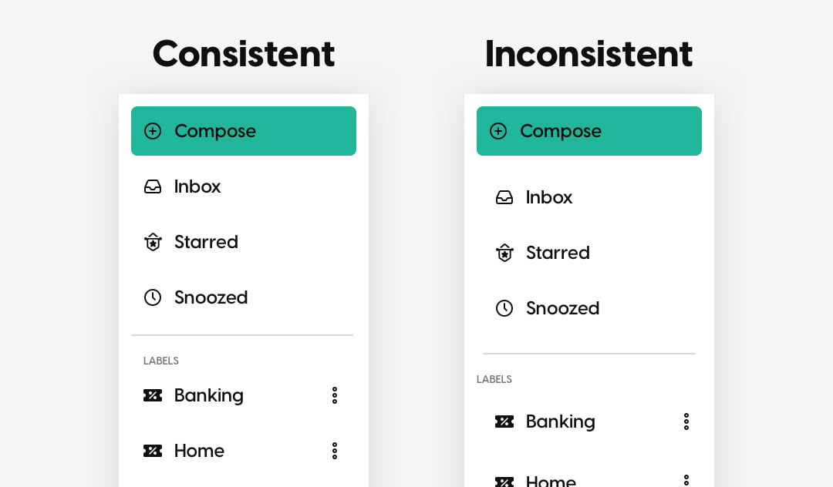

* **Color Principles**

Contrast: Ensure high contrast between text and background for readability.

Color Harmony: Choose colors that work well together and are visually pleasing.

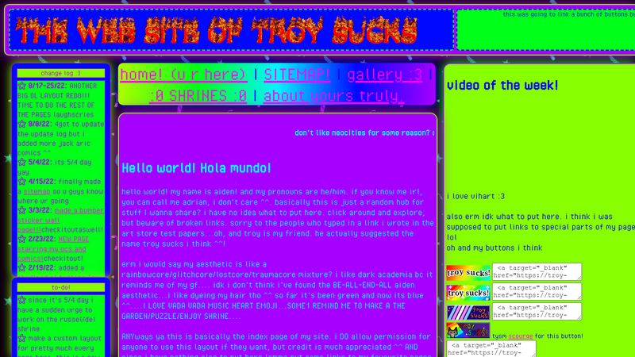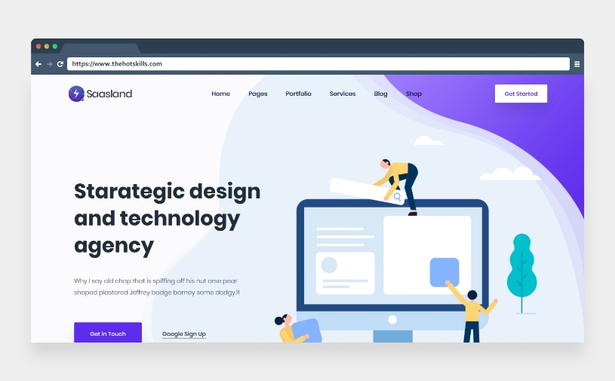

Emphasis: Use color to highlight important elements like buttons or alerts.

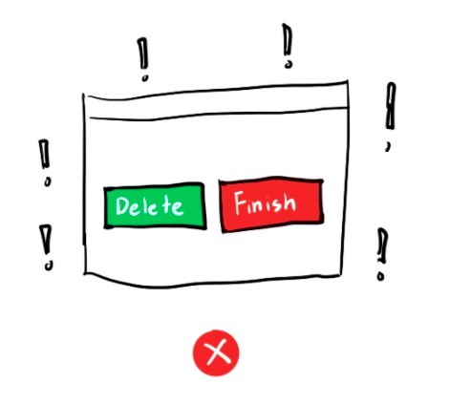

*Website for colours combinations:* [*Color Hunt - Color Palettes for Designers and Artists*](https://colorhunt.co/)

* **Usability**

Intuitive Navigation: Ensure navigation is easy to find and use.

Readability: Choose readable fonts and sizes.

1. **Activities**

In this lab, you will create a simple login page as part of your exercise with HTML and CSS. The goal is to design a user-friendly and visually appealing webpage while applying key principles of Human-Computer Interaction (HCI).

* **Exercise 1: HTML**

**Objective:**

You will create a basic login page using HTML. This exercise will help you understand how to structure a webpage and apply HCI principles to ensure it is user-friendly.

Step 1: Download the html file (“Lab3.html”)

Step 2: Rename it to (“Your Name – Lab3.html”)

Step 3**:** Edit the file to create a basic structure for your login page, including:

* A form with fields for Username and Password with their labels.
* A Submit button.
* A Forgot Password link.
* **Exercise 2: CSS**

Step 1: Download the css file (“Lab3.css”)

Step 2: Rename it to (“Your Name – Lab3.css”)

Step 3: Link this CSS file to your HTML file.

Step 4: Style Your Login Page:

* Implement Design Principles**:** Use the CSS file to style your login page, focusing on visual elements like color, layout, and typography.
* Adjust Colors and Layout: Ensure your design follows principles like contrast, simplicity, and alignment, making the page user-friendly and visually appealing.

(**Note: You can create your own styles and structure for the login page. The provided HTML and CSS files are just a starting point to guide you. Feel free to innovate, personalize, and enhance the design and layout of your page according to your preferences.)**

**Submission:** Make sure to apply the design principles discussed and verify that your login page is functional and visually appealing. Submit both the HTML and CSS files.

1. **References**

[**HTML Tutorial (w3schools.com)**](https://www.w3schools.com/html/)

[**Color Hex - ColorHexa.com**](https://www.colorhexa.com/)

[**CSS Tutorial (w3schools.com)**](https://www.w3schools.com/css/default.asp)

[**CSS Tricks**](https://css-tricks.com/)

[**MDN Web Docs: HTML**](https://developer.mozilla.org/en-US/docs/Web/HTML)

[**MDN Web Docs: CSS**](https://developer.mozilla.org/en-US/docs/Web/CSS)